FSD - Developing a Reliable Back-end with Node and Express
Day 6:

Web Service : Giving the service for web application when both application running or develop using other language or same language.
Req (Java Req)---
Web App1 Web App2
BankOfIndia XML/JSON BankOfAmerica
Java Python or Node Express JS
--Res(Python or Node Express)

These two format we use to share the data.
XML : eXtensible markup language :
JSON : JavaScript Object Notation :
Types of Web Service
2
- SOAP Base Web Service
Simple Object Access Protocol : SOAP is a protocol. SOAP base upon SOA (Service Oriented Architecture). In SOAP Web Service we need to share the data only in the form XML.

- Rest Full Web Service : Representation State Transfer. In Rest full web service we can share the data between to technologies in any format base upon client or application requirement. In Rest Web Service we can consume or produce data in xml, json, plan text, html or an other media type.

Using Rest Full Web Service we need to create API or Rest API
Rest full web service use http protocol methods. Ie Get, Post, Put, Patch and Delete etc.

Get Method: Get the resource of Product, Customer, Employee, Account etc in the form of XML or JSON.
URL: it provide all product or customer or any other object in the form of XML or JSON.
Find particular resource details using unique property or any other property
Query Param
URL?key=value;
URL?key=value&key=value;
Path Param
URL/value
URL/value1/value2

Creating Simple Rest API to produce data in different format with help of Get method ie plain text, html and json etc.
Mkdir simple-rest-api-data-format
Npm init -y
Npm install express

Creating another rest api project to get the resource as well as search the resource using query param and path param technique.

Mkdir rest-api-get-resources
Npm init -y
Npm install express

To test rest api apart from Get API we need rest api plugin.
Post Man : Post man is one of the api testing plugin
Or
CURL Non window terminal allow to test rest api.

Get Method : get the resource :
Select query if we connect to database.
Post Method : create the resource mean store the data in array or file system or database.
Insert query If we connect to database.
Put method or Patch method: put/patch method is use to update the existing resource using unique property.
Update query if we connect to database.
Patch is use to update partial property and put is use to update all property.
Update salary using id property use patch method
Update salary and name using id property then use put method.
Delete method : delete the resource using unique property with query param or path param.
delete query if we connect to database.
Creating rest api for employee to store, delete, update and retrieve using api with array concept.
Mkdir employee_rest_api
Npm init -y
Npm install express

Post method testing using post man client

Header

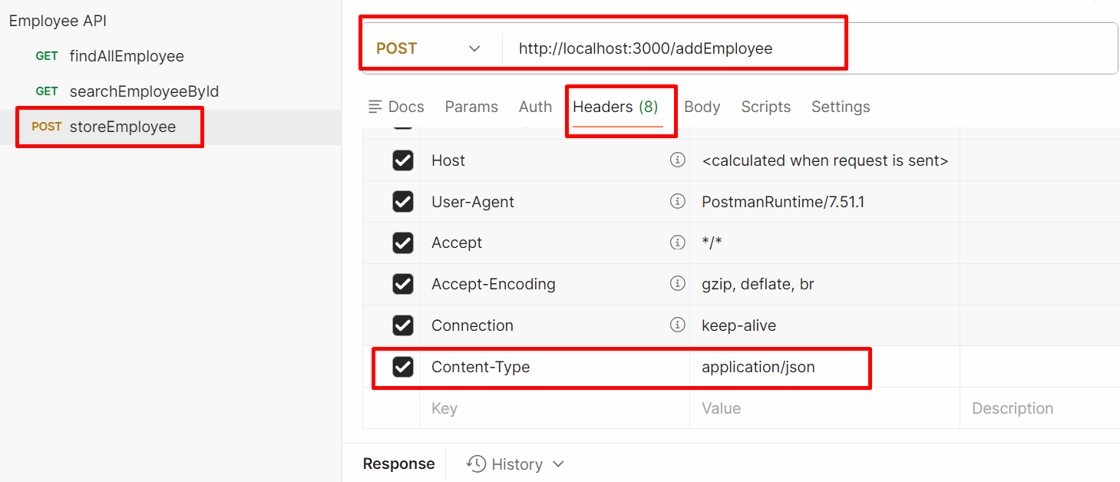

Body

